DENOISING OF IMAGE USING BIEMPIRICAL MODE DECOMPOSITION

Project Report Submitted in partial fulfilment for the degree of

Bachelor of Technology in Electrical and Electronics Engineering

By

ABINASH PANDA, 1641014033

ABHILASH KAR, 1641014069

DEPARTMENT OF ELECTRICAL AND ELECTRONICS ENGINEERING

Institute of Technical Education and Research

SIKSHA ‘O’ ANUSANDHAN (Deemed to be) UNIVERSITY

Bhubaneswar, Odisha, India

(May, 2020)

DENOISING OF IMAGE USING BIEMPIRICAL MODE DECOMPOSITION

Project Report Submitted in partial fulfilment for the degree of

Bachelor of Technology in Electrical and Electronics Engineering

By

ABINASH PANDA, 1641014033

ABHILASH KAR, 1641014069

DEPARTMENT OF ELECTRICAL AND ELECTRONICS ENGINEERING

Institute of Technical Education and Research

SIKSHA ‘O’ ANUSANDHAN (Deemed to be) UNIVERSITY

Bhubaneswar, Odisha, India

(May, 2020)

CERTIFICATE

This is to certify that the project titled”Denoising of image using Biempirical mode Decomposition “Submitted by Abinash Panda & Abhilash Kar to the Institute of Technical Education & Research, SIKSHA ‘O’ ANUSANDHAN (Deemed to be) University, Bhubaneswar for the partial fulfilment for the degree of Bachelor of Technology in Electrical and Electronics Engineering is a record of original bonafide work carried out by them under my supervision and guidance. The Project work in my opinion has reached the requisite standard, fulfilling the requirements for the degree of Bachelor of Technology. The Result contained in this thesis have not been submitted in part or full to any other university or institute for the award of any degree or diploma

Niranjan Nayak Lalita Mohan Satapathy

Dept. of EEE Dept.of EEE

ITER ITER

ACKNOWLEDGEMENT

The brain power of student can be developed only through education. It helps to improve the inner potentiality of the student or gain on deeper knowledge. The project is such a medium to improve the standard of the students not only theoretically but also practically as it is the part and parcel of school education. I am very thankful to my teacher Mr Lalit Mohan Satapathy to assign a project based on “Denoising of image using Biempirical Mode Decomposition” on his complete supervision at the same time I am very much grateful towards my parents, friends and relatives who inspired and supported me whole heartedly to complete this Project work.

DECLARATION

We hereby declare that this written submission report represents our ideas in our own words and where other’s ideas and words have been included. We have adequately cited and referenced the original sources. We also declare that we have adhered to all the principles of academic honesty and integrity and have not misrepresented or fabricated or falsified any idea / source / fact in our submission.

We understand any violation of the above will be cause for disciplinary action by the University and can also evoke penal action from the sources which have thus not been properly cited or from whom proper permission have not been taken when needed.

Abinash Panda Abhilash Kar

Regd No: 1641014033 Regd no: 1641014069

Date: Date:

REPORT APPROVAL

This project report entitled “Denoising of image using Biempirical Mode Decomposition” by Abinash Panda and Abhilash Kar is approved for the degree of Bachelor of Technology in Electrical and Electronics Engineering.

Examiners

Supervisors

H.O.D.

Date: 16 May 2020

Place: Bhubaneswar

ABSTRACT (Modify)

In this Project we have done about the image decomposing and denoising of a bio-medical image. In this method we improve the image quality and it also retrieves the lost data due to noise. The proposed algorithm first decomposes the original image (I) into low frequency and high-frequency components using BEMD, where the low frequency and high-frequency components stand for detail and approximation information. In our proposed method we use BEMD where we decompose an image into three parts of IMF’s and one part of residue. The residue contains edge information of the original image. In the traditional method we used to directly apply the filter to the image to improve the quality. In our proposed method we first decompose the image into four parts by using BEMD and we apply filters to three IMF’s individually and the add all the three filtered decomposed images with the residue image and get a new image which has better quality than the image obtained from the traditional method. Firstly BEMD takes the high frequency and low frequency of the original image and divides it by two to get the IMF1 and then it subtract the mean from the original image and then from the rest of the subtracted image then it repeats the process to get IMF2 and IMF3 and the part which is left is the residue image.

LIST OF TABLES

|  |  |  |
| --- | --- | --- |
| Slno. | Table Name | Table No. |
| 1 | Comparison b/w normal and noisy image (Gaussian noise with variance-0.01, Mean-0) using median filter | 1.1 |
| 2 | Comparison b/w normal and noisy image (Gaussian noise with variance-0.01, Mean-0) using Gaussian filter | 1.2 |
| 3 | Comparison b/w normal and noisy image (Gaussian noise with variance-0.01, Mean-0) using fspecial filter | 1.3 |
| 4 | Comparison b/w normal and noisy image (Speckle noise with variance-0.1, Mean-0) using median filter | 1.4 |
| 5 | Comparison b/w normal and noisy image (Speckle noise with variance-0.1, Mean-0) using Gaussian filter | 1.5 |
| 6 | Comparison b/w normal and noisy image (Speckle noise with variance-0.1, Mean-0) using fspecial filter | 1.6 |
| 7 | Comparison b/w normal and noisy image (Salt Pepper noise with variance-0.1, Mean-0) using median filter | 1.7 |
| 8 | Comparison b/w normal and noisy image (Salt Pepper noise with variance-0.1, Mean-0) using Gaussian filter | 1.8 |
| 9 | Comparison b/w normal and noisy image (Salt Pepper noise with variance-0.1, Mean-0) using fspecial filter | 1.9 |

LIST OF FIGURE

|  |  |  |
| --- | --- | --- |
| Slno. | Figure Name | Fig No. |
| 1 | Performance of MRI brain images (a) IMF1 (b) IMF2 (c) IMF3 (d) Residue | 1.1 |
| 2 | Performance of MRI brain images (a) Input image (b) Noisy image (Gaussian noise with variance 0.01) | 1.2 |
| 3 | Performance of MRI brain images (a) Input image (b) Noisy image (Speckle noise with variance 0.1) | 1.3 |
| 4 | Performance of MRI brain images (a) Input image (b) Noisy image (Salt and Pepper noise with variance 0.01) | 1.4 |
| 5 | Performance of MRI brain images (a) Input image (b) Noisy image (Gaussian noise with variance 0.01) (c) applying median filter (d) Applying fspecial filter (e) Applying Gaussian (f) Proposed method. | 1.5 |
| 6 | Performance of MRI brain images (a) Input image (b) Noisy image (Speckle noise with variance 0.1) (c) applying median filter (d) Applying fspecial filter (e) Applying Gaussian (f) Proposed method | 1.6 |
| 7 | Performance of MRI brain images (a) Input image (b) Noisy image (Salt and pepper noise with variance 0.1) (c) applying median filter (d) Applying fspecial filter (e) Applying Gaussian (f) Proposed method. | 1.7 |

|  |  |  |
| --- | --- | --- |
| Slno. | Symbol | Symbol No. |
|  |  |  |
|  |  |  |
|  |  |  |
|  |  |  |
|  |  |  |
|  |  |  |
|  |  |  |
|  |  |  |
|  |  |  |

LIST OF SYMBOL

Contents

|  |  |  |
| --- | --- | --- |
| Slno. | Chapter | Page no |
| 1 | Introduction |  |
| 2 | Literature Survey |  |
| 3 | Concept Generation |  |
| 4 | Project Modelling & Simulation |  |
| 5 | Result |  |
| 6 | Conclusion |  |
| 7 | Individual & Group Learning |  |
| 8 | Reference |  |
| 9 | Appendix |  |

INTRODUCTION

Image Denoising is one of the fundamental challenges in the field of image processing and computer vision, where the underlying goal is to estimate the original image by suppressing noise from a noise-contaminated version of the image. In Image Denoising we try to remove the noise from an image by using certain techniques so as to recovers the original image by retaining its quality, which gets corrupted during its acquisition or transmission. Therefore, image denoising plays an important role in a wide range of applications such as image restoration, visual tracking, image registration, image segmentation, and image classification, where obtaining the original image content is crucial for strong performance.  Noisy images are generally produced during medical procedures which require instruments to produce detailed pictures of the inside of your body such as MRI, CT scan, ultrasound, x-ray etc. In medical operation it is important to denoise an image so as to recover the suppressed anatomical details due to the noise. Bio-medical images are normally - corrupted with noise; which degrades the useful detail of medical images which may affect the diagnosis. In Bio-medical images the denoising should be done by balanced edge preservation as edges are an important aspect of the image. Thus, all medical imaging devices need denoising technique to enhance the image quality which will help the doctors and medical experts for proper diagnosis. In traditional denoising techniques, to improve the quality of the image the filter such as Median filter, Gaussian filter and Fspecial filter are directly applied over noisy image. But in our proposed method we first decompose the noisy image using BEMD (Bi dimensional Empirical Mode Decomposition) then we filter out the three images obtained from the decomposed image and add it to make a new and better image which recovers more details of the original image than the traditional method. In traditional method we directly apply the filter to the noisy image but in our proposed method we decompose the image into four parts using BEMD then we apply the filter to the IMF1, IMF2, IMF3 individually and adding these three images with residue image we get a better quality image than the traditional method. In our proposed method we have used BEMD instead of DWT (Discrete Wavelet Transform) because [1]. IDWT (Inverse Discrete Wavelet Transform) is required to reconstruct the image from the decomposed images and [2]. DWT is an image independent technique.

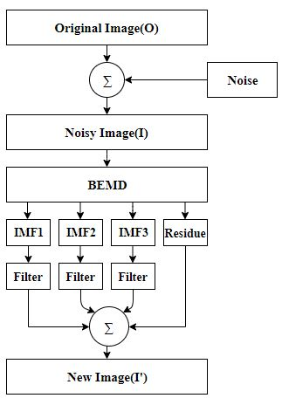

LITERATURE SURVEY

CONCEPT GENERATION & SELECTION

The proposed method gives us a brief idea about the image decomposing and denoising of a bio-medical image. In this method we improve the image quality and it also retrieves the lost data due to noise. The proposed algorithm first decomposes the original image (I) into low frequency and high-frequency components using BEMD, where the low frequency and high-frequency components stand for detail and approximation information. In our proposed method we use BEMD where we decompose an image into three parts of IMF’s and one part of residue. The residue contains edge information of the original image. In the traditional method we used to directly apply the filter to the image to improve the quality. In our proposed method we first decompose the image into four parts by using BEMD and we apply filters to three IMF’s individually and the add all the three filtered decomposed images with the residue image and get a new image which has better quality than the image obtained from the traditional method. Firstly BEMD takes the high frequency and low frequency of the original image and divides it by two to get the IMF1 and then it subtract the mean from the original image and then from the rest of the subtracted image then it repeats the process to get IMF2 and IMF3 and the part which is left is the residue image.

PROJECT MODELLING & SIMULATION

BEMD:-BEMD is to decompose bi-dimensional image into intrinsic mode functions (IMFs) and residue like one dimensional EMD. Someone used EMD to image denoising, which viewed the image as one dimensional row signals. The overall process can be broken down into four steps. First, images are decomposed using BEMD arithmetic to extract the [Intrinsic Mode Functions](https://www.sciencedirect.com/topics/engineering/intrinsic-mode-function) (IMFs). Then, these IMFs could be examined using gradual single frequency signals to bring out and highlight the physical meaning of [instantaneous amplitudes](https://www.sciencedirect.com/topics/computer-science/instantaneous-amplitude) and frequencies. The detailed process can be described as follows

1. Look for the local extremum and form the envelopments of the original image $f\left(x,y\right)$.
2. Compute the average $m_{1}\left(x,y\right)$ of the top envelopment and bottom envelopment and denote that $l_{1}\left(x,y\right)=f\left(x,y\right)-m_{1}\left(x,y\right)$
3. Replace $f\left(x,y\right)$ with $l_{1}$ (x, y) and execute the above three steps. Then we can get $l_{i}\left(x,y\right)$) until the standard deviation SD is smaller than the threshold predefined. We used $l_{1}$ (x,y) to replace $l_{i}\left(x,y\right)$.If the local mean of $l_{i}\left(x,y\right)$ is zero, we view it as ${imf}_{1 },where$

SD= $\sum_{x=0}^{x}{\sum_{y=0}^{y}{\left(\frac{{{[l}_{i+1}\left(x,y\right)-l_{i}(x,y)]}^{2}}{{l_{i}}^{2}(x,y)}\right)}}$

1. 4) Replace $f\left(x,y\right)$ with $f\left(x,y\right)$- $I_{1}(x,y)$ and execute the above four steps until the extremum number of residue is smaller than two. Then we complete the decomposition.

$f\left(x,y\right)$ = $\sum_{i=1}^{N}{imf\left(x,y\right)+}r_{n}(x,y)$

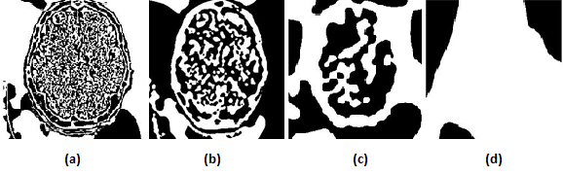

Performance of MRI brain images (a) IMF1 (b) IMF2 (c) IMF3 (d) Residue

(Fig-1.1)

MSE:

The MSE represents the cumulative squared error between the compressed and the original image. The lower the value of MSE, the lower the error and better quality of compressed image. It is calculated as:

$$MSE=\frac{1}{pq}\sum_{a=0}^{p-1}{\sum_{b=0}^{q-1}{[I\left(a,b\right)-K(a,b)]^{2}}}$$

Where *p q*: Dimension of the image.

I (a, b): Intensity of pixels (a, b) in original image.

K (a, b): Intensity of pixels (a, b) in de-noising image.

PSNR:-

Peak signal-to-noise ratio, is the ratio between the maximum possible power of a [signal](https://en.wikipedia.org/wiki/Signal_(information_theory)) and the power of corrupting [noise](https://en.wikipedia.org/wiki/Noise) that affects the fidelity of its representation. PSNR is most commonly used to measure the quality of reconstruction of lossy compression [codecs](https://en.wikipedia.org/wiki/Codec) (for [image compression](https://en.wikipedia.org/wiki/Image_compression)). The signal in this case is the original data, and the noise is the error introduced by compression. When comparing compression codecs, PSNR is an approximation to human perception of reconstruction quality. Higher the value of PSNR, better the quality of compressed image. PSNR is calculated as:

$${PSNR}_{db}=10\log_{10}(\frac{{MAX}^{2}}{MSE})$$

= $20\log_{10}(MAX)- 10\log_{10}(MSE)$

Where,

MAX: Maximum possible pixel value of the image.

MSE: Mean Square Error

SSIM:-

Structural similarity index (SSIM) is a method for predicting the perceived quality of digital television and cinematic pictures, as well as other kinds of digital images and videos. It is used for measuring the similarity between two images. It’s a [full reference metric](https://en.wikipedia.org/wiki/Video_quality#Classification_of_objective_video_quality_metrics) and perception based model that considers image degradation as perceived change in structural information, while also incorporating important perceptual phenomena, including both luminance masking and contrast masking terms.

$$SSIM(a,b)=[q(a,b)]^{α}[w(a,b)]^{α} [e (a,b){] }^{γ}$$

Where,

$$q(a,b)=\frac{2μ_{a}μ_{b}+c1}{μ_{a^{2}+μ_{b^{2}}+C1}}$$

$$W(a,b)=\frac{2δ_{a}δ_{b}+c2}{δ_{a^{2}}+δ_{b^{2}}+c2}$$

$$e(a,b)=\frac{δ_{ab}+c3}{δ_{a}δ_{b}+c3}$$

Where,

$$μ_{a}=Local mean for iamge a$$

$$μ_{b}=local mean for image b$$

$$δ_{a}=standrad deviation for image a$$

$δ_{ab }$ = cross co-variance for image a,b

$${ δ}_{b}= standrad deviation for image b$$

If α = β = γ = 1 and C3 = C2/2 then the above index is simplifying to:

SSIM = $\frac{(2μ_{a}μ_{b}+c1)(2δ_{a}δ_{b}+c2)}{{{(μ}_{a}}^{2}+{μ_{b}}^{2}+c1)({δ_{a}}^{2}+{δ_{b}}^{2}+c2)}$

RESULT

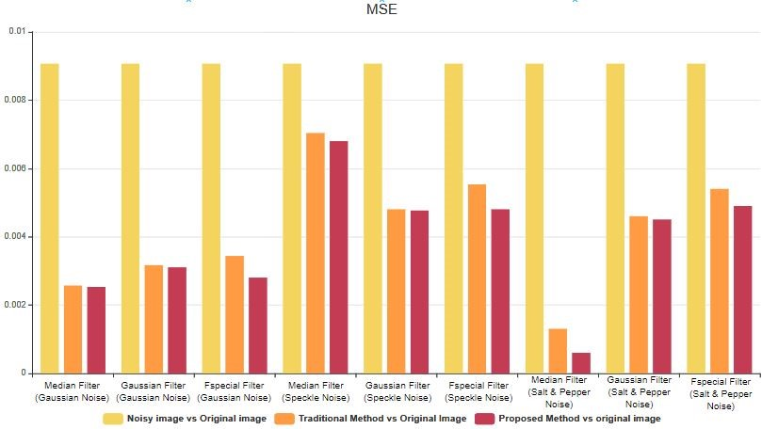

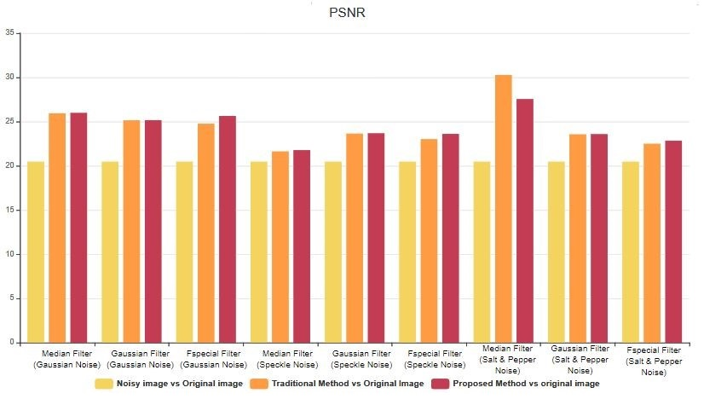

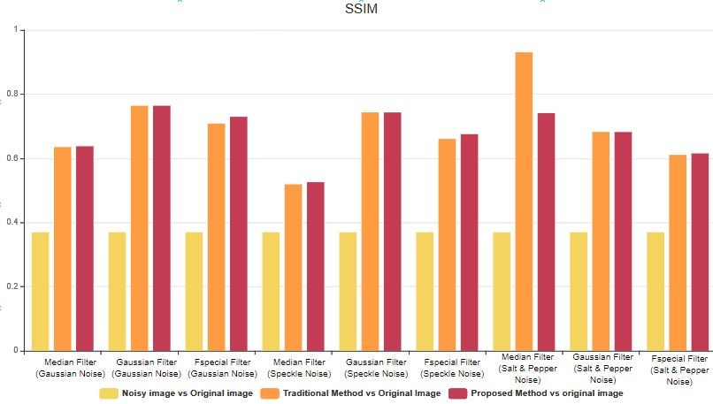

|  |  |  |  |  |  |  |  |  |  |
| --- | --- | --- | --- | --- | --- | --- | --- | --- | --- |
| Slno. | Compare b/w normal & noisy image | | | Compare b/w normal & Filter image (Median Filter) | | | Comparison b/w normal & Proposed Metho d | | |
| Image | Mse | Psnr | Ssim | Mse | Psnr | Ssim | Mse | Psnr | Ssim |
| 1 | 0.01 | 20.0154 | 0.282 | 0.0025 | 25.9617 | 0.5461 | 0.0025 | 25.9675 | 0.5412 |
| 2 | 0.008 | 20.9856 | 0.396 | 0.0029 | 25.4157 | 0.6379 | 0.0028 | 25.4739 | 0.6471 |
| 3 | 0.0092 | 20.3642 | 0.429 | 0.0023 | 26.4185 | 0.7197 | 0.0023 | 26.4687 | 0.7226 |

Comparison b/w normal and noisy image (Gaussian noise with variance-0.01, Mean-0) using median filter

(Table-1.1)

|  |  |  |  |  |  |  |  |  |  |
| --- | --- | --- | --- | --- | --- | --- | --- | --- | --- |
| Slno | Compare b/w normal & noisy image | | | Compare b/w normal & Filter image (Gaussian Filter) | | | Comparison b/w normal & Proposed Method | | |
| Image | Mse | Psnr | Ssim | Mse | Psnr | Ssim | Mse | Psnr | Ssim |
| 1 | 0.01 | 20.0201 | 0.28 | 0.0024 | 26.237 | 0.7706 | 0.0024 | 26.239 | 0.769 |
| 2 | 0.008 | 20.9532 | 0.39 | 0.004 | 23.9965 | 0.7553 | 0.0039 | 24.0461 | 0.7557 |
| 3 | 0.0091 | 20.4037 | 0.42 | 0.0031 | 25.1508 | 0.7644 | 0.003 | 25.1918 | 0.7651 |

Comparison b/w normal and noisy image (Gaussian noise with variance-0.01, Mean-0) using Gaussian filter

(Table-1.2)

Comparison b/w normal and noisy image (Gaussian noise with variance-0.01, Mean-0) using Fspecial filter

(Table-1.3)

|  |  |  |  |  |  |  |  |  |  |
| --- | --- | --- | --- | --- | --- | --- | --- | --- | --- |
| Slno. | Compare b/w normal & noisy image | | | Compare b/w normal & Filter image (Fspecial Filter) | | | Comparison b/w normal & Proposed Method | | |
| Image | Mse | Psnr | Ssim | Mse | Psnr | Ssim | Mse | Psnr | Ssim |
| 1 | 0.0099 | 20.0524 | 0.28 | 0.0025 | 25.9572 | 0.6596 | 0.0022 | 26.5949 | 0.69 |
| 2 | 0.008 | 20.9714 | 0.39 | 0.0045 | 23.4865 | 0.7111 | 0.0035 | 24.6044 | 0.731 |
| 3 | 0.0092 | 20.3739 | 0.43 | 0.0033 | 24.7912 | 0.7533 | 0.0027 | 25.6741 | 0.764 |

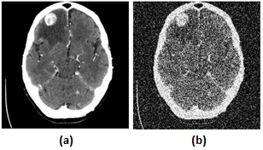

(Fig-1.2)

Performance of MRI brain images (a) Input image (b) Noisy image (Gaussian noise with variance 0.01)

|  |  |  |  |  |  |  |  |  |  |
| --- | --- | --- | --- | --- | --- | --- | --- | --- | --- |
| Slno | Compare b/w normal & noisy image | | | Compare b/w normal & Filter image (Median Filter) | | | Comparison b/w normal & Proposed Method | | |
| Image | Mse | Psnr | Ssim | Mse | Psnr | Ssim | Mse | Psnr | Ssim |
| 1 | 0.018 | 17.4547 | 0.20 | 0.0059 | 22.3243 | 0.3897 | 0.0057 | 22.4673 | 0.399 |
| 2 | 0.0244 | 16.1321 | 0.39 | 0.0088 | 20.5709 | 0.5433 | 0.0085 | 20.73 | 0.549 |
| 3 | 0.0203 | 16.9301 | 0.41 | 0.0064 | 21.9478 | 0.6222 | 0.0062 | 22.0709 | 0.626 |

Comparison b/w normal and noisy image (Speckle noise with variance-0.1, Mean-0) using Median filter

(Table-1.4)

|  |  |  |  |  |  |  |  |  |  |
| --- | --- | --- | --- | --- | --- | --- | --- | --- | --- |
| Slno | Compare b/w normal & noisy image | | | Compare b/w normal & Filter image (Gaussian Filter) | | | Comparison b/w normal & Proposed Method | | |
| Image | Mse | Psnr | Ssim | Mse | Psnr | Ssim | Mse | Psnr | Ssim |
| 1 | 0.0181 | 17.4258 | 0.2008 | 0.0028 | 25.5112 | 0.7499 | 0.0028 | 25.5387 | 0.749 |
| 2 | 0.0245 | 16.11 | 0.3953 | 0.008 | 20.9684 | 0.7164 | 0.0079 | 21.0025 | 0.716 |
| 3 | 0.0204 | 16.8999 | 0.4143 | 0.0036 | 24.4167 | 0.7616 | 0.0036 | 24.4466 | 0.761 |

|  |  |  |  |  |  |  |  |  |  |
| --- | --- | --- | --- | --- | --- | --- | --- | --- | --- |
| Slno | Compare b/w normal & noisy image | | | Compare b/w normal & Filter image (Fspecial Filter) | | | Comparison b/w normal & Proposed Method | | |
| Image | Mse | Psnr | Ssim | Mse | Psnr | Ssim | Mse | Psnr | Ssim |
| 1 | 0.018 | 17.4372 | 0.20 | 0.0032 | 24.9153 | 0.6123 | 0.0029 | 25.4013 | 0.640 |
| 2 | 0.0246 | 16.0942 | 0.39 | 0.0091 | 20.4286 | 0.6404 | 0.0078 | 21.0556 | 0.650 |
| 3 | 0.0203 | 16.9223 | 0.41 | 0.0043 | 23.6575 | 0.727 | 0.0037 | 24.3292 | 0.734 |

Comparison b/w normal and noisy image (Speckle noise with variance-0.1, Mean-0) using Gaussian filter

(Table-1.5)

Comparison b/w normal and noisy image (Speckle noise with variance-0.1, Mean-0) using fspecial filter

(Table-1.6)

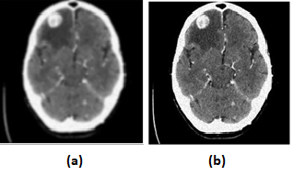

(Fig-1.3)

Performance of MRI brain images (a) Input image (b) Noisy image (Speckle noise with variance 0.1)

Comparison b/w normal and noisy image (Salt Pepper noise with variance-0.1, Mean-0) using Median filter

|  |  |  |  |  |  |  |  |  |  |
| --- | --- | --- | --- | --- | --- | --- | --- | --- | --- |
| Slno | Compare b/w normal & noisy image | | | Compare b/w normal & Filter image (Median Filter) | | | Comparison b/w normal & Proposed Method | | |
| Image | Mse | Psnr | Ssim | Mse | Psnr | Ssim | Mse | Psnr | Ssim |
| 1 | 0.0274 | 15.6223 | 0.19 | 0.0008 | 30.7485 | 0.9262 | 0.0018 | 27.5388 | 0.666 |
| 2 | 0.0374 | 14.2673 | 0.25 | 0.0016 | 28.057 | 0.9136 | 0.0024 | 26.1131 | 0.717 |
| 3 | 0.0316 | 15.0056 | 0.28 | 0.0006 | 32.016 | 0.9496 | 0.0013 | 28.9529 | 0.837 |

(Table-1.7)

Comparison b/w normal and noisy image (Salt Pepper noise with variance-0.1, Mean-0) using Gaussian Filter

|  |  |  |  |  |  |  |  |  |  |
| --- | --- | --- | --- | --- | --- | --- | --- | --- | --- |
| Slno | Compare b/w normal & noisy image | | | Compare b/w normal & Filter image (Gaussian Filter) | | | Comparison b/w normal & Proposed Method | | |
| Image | Mse | Psnr | Ssim | Mse | Psnr | Ssim | Mse | Psnr | Ssim |
| 1 | 0.0279 | 15.539 | 0.19 | 0.0033 | 24.8542 | 0.6968 | 0.0033 | 24.8478 | 0.695 |
| 2 | 0.0375 | 14.2564 | 0.24 | 0.0058 | 22.3857 | 0.6541 | 0.0057 | 22.407 | 0.6538 |
| 3 | 0.0325 | 14.8766 | 0.27 | 0.0046 | 23.4012 | 0.6946 | 0.0045 | 23.4427 | 0.695 |

(Table-1.8)

|  |  |  |  |  |  |  |  |  |  |
| --- | --- | --- | --- | --- | --- | --- | --- | --- | --- |
| Slno | Compare b/w normal & noisy image | | | Compare b/w normal & Filter image (Fspecial Filter) | | | Comparison b/w normal & Proposed Method | | |
| Image | Mse | Psnr | Ssim | Mse | Psnr | Ssim | Mse | Psnr | Ssim |
| 1 | 0.0325 | 14.8766 | 0.27 | 0.0046 | 23.4012 | 0.6946 | 0.0045 | 23.4427 | 0.695 |
| 2 | 0.0372 | 14.2904 | 0.24 | 0.0073 | 21.3723 | 0.5149 | 0.0065 | 21.9038 | 0.521 |
| 3 | 0.0314 | 15.036 | 0.28 | 0.0054 | 22.675 | 0.6209 | 0.0049 | 23.1157 | 0.627 |

Comparison b/w normal and noisy image (Salt Pepper noise with variance-0.1, Mean-0) using Fspecial Filter

(Table-1.9)

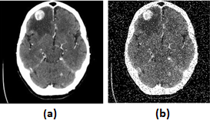

(Fig-1.4)

Performance of MRI brain images (a) Input image (b) Noisy image (Salt and Pepper noise with variance 0.01)

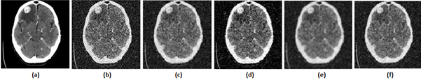

(Fig-1.5)

Performance of MRI brain images (a) Input image (b) Noisy image (Gaussian noise with variance 0.01) (c) applying median filter (d) Applying fspecial filter (e) Applying Gaussian (f) Proposed method.

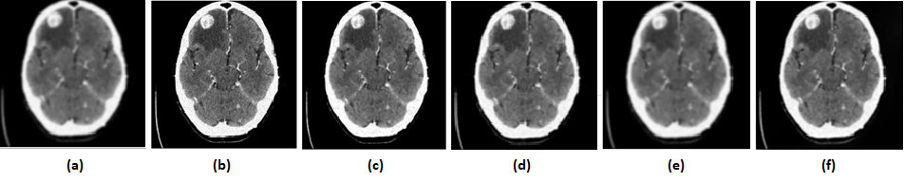

(Fig-1.6)

Performance of MRI brain images (a) Input image (b) Noisy image (Speckle noise with variance 0.1) (c) applying median filter (d) Applying fspecial filter (e) Applying Gaussian (f) Proposed method

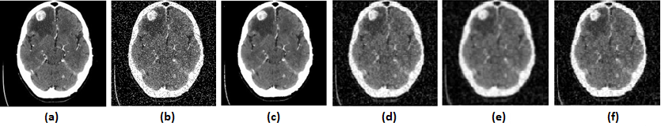

(Fig-1.7)

Performance of MRI brain images (a) Input image (b) Noisy image (Salt and pepper noise with variance 0.1) (c) applying median filter (d) Applying fspecial filter (e) Applying Gaussian (f) Proposed method.

CONCLUSION & SCOPE OF FUTURE WORK

INDIVIDUAL AND GROUP LEARNING

Group Learning: The work distribution is predetermined, which helped us to specifically focus on our individual work. Group work helped each individuals to share their liabilities with the group, which in return helped the group to progress towards the end goal, which means the completion. Group project encourages us to feel proud of our contribution. Tackling obstacles and creating notable work together made our group feel more fulfilled.

Member 1: As an individual group member, I learned to work on different functions of MATLAB.Also learned about various technology used in image processing and how image processing is very much essential for Todays Era. Also got to learned about various noise and various filter used in image processing.

Member 2:

REFERENCES

1.